**Java 8 to 19 Changes**

**Local-Variable Type Inference JDK 10**

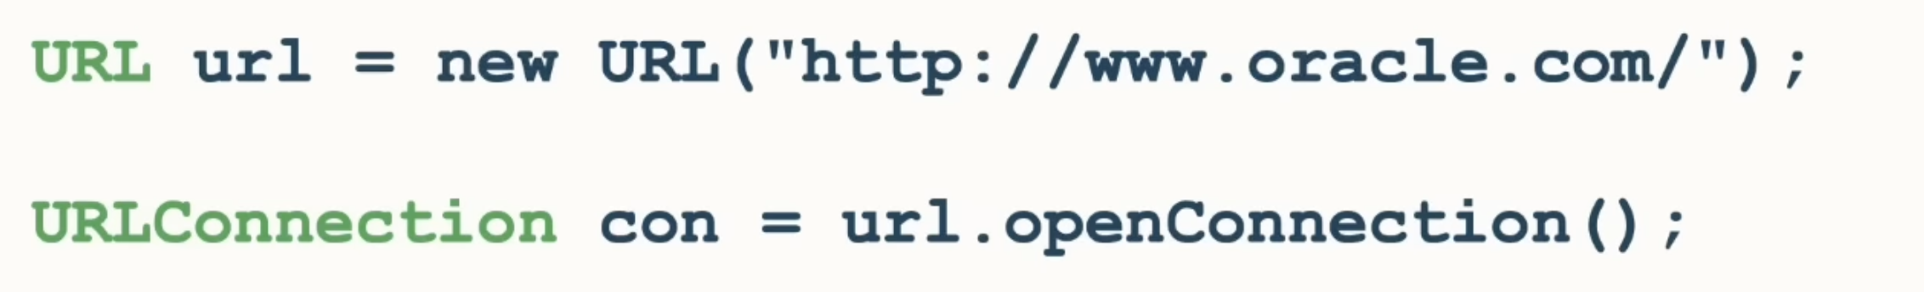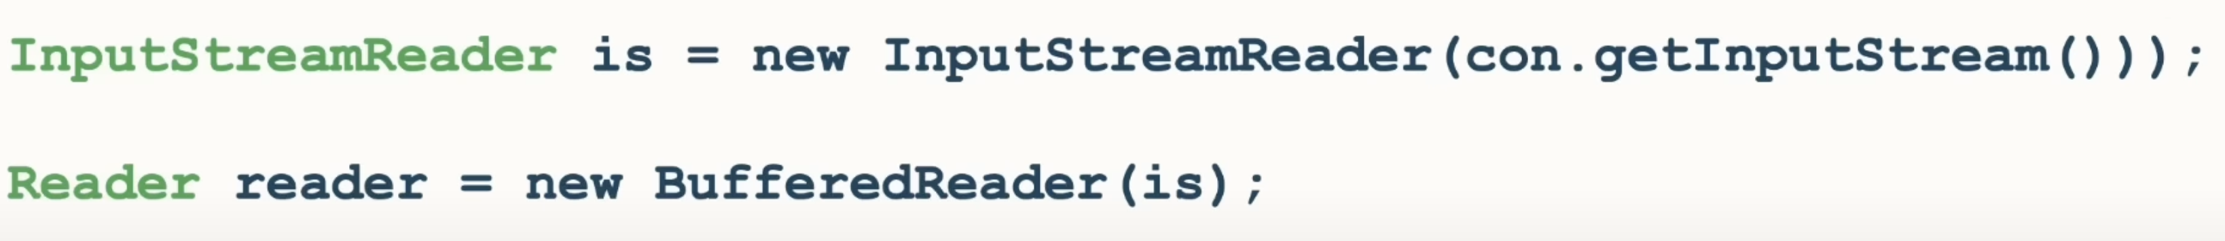

It can be written as:

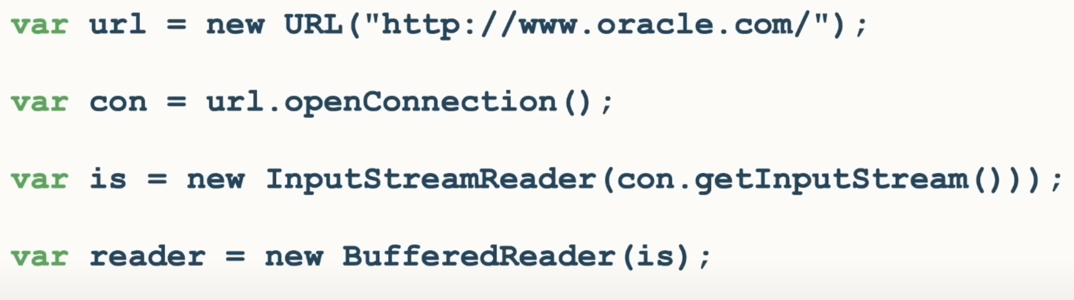

**Switch Expression JDK 14**

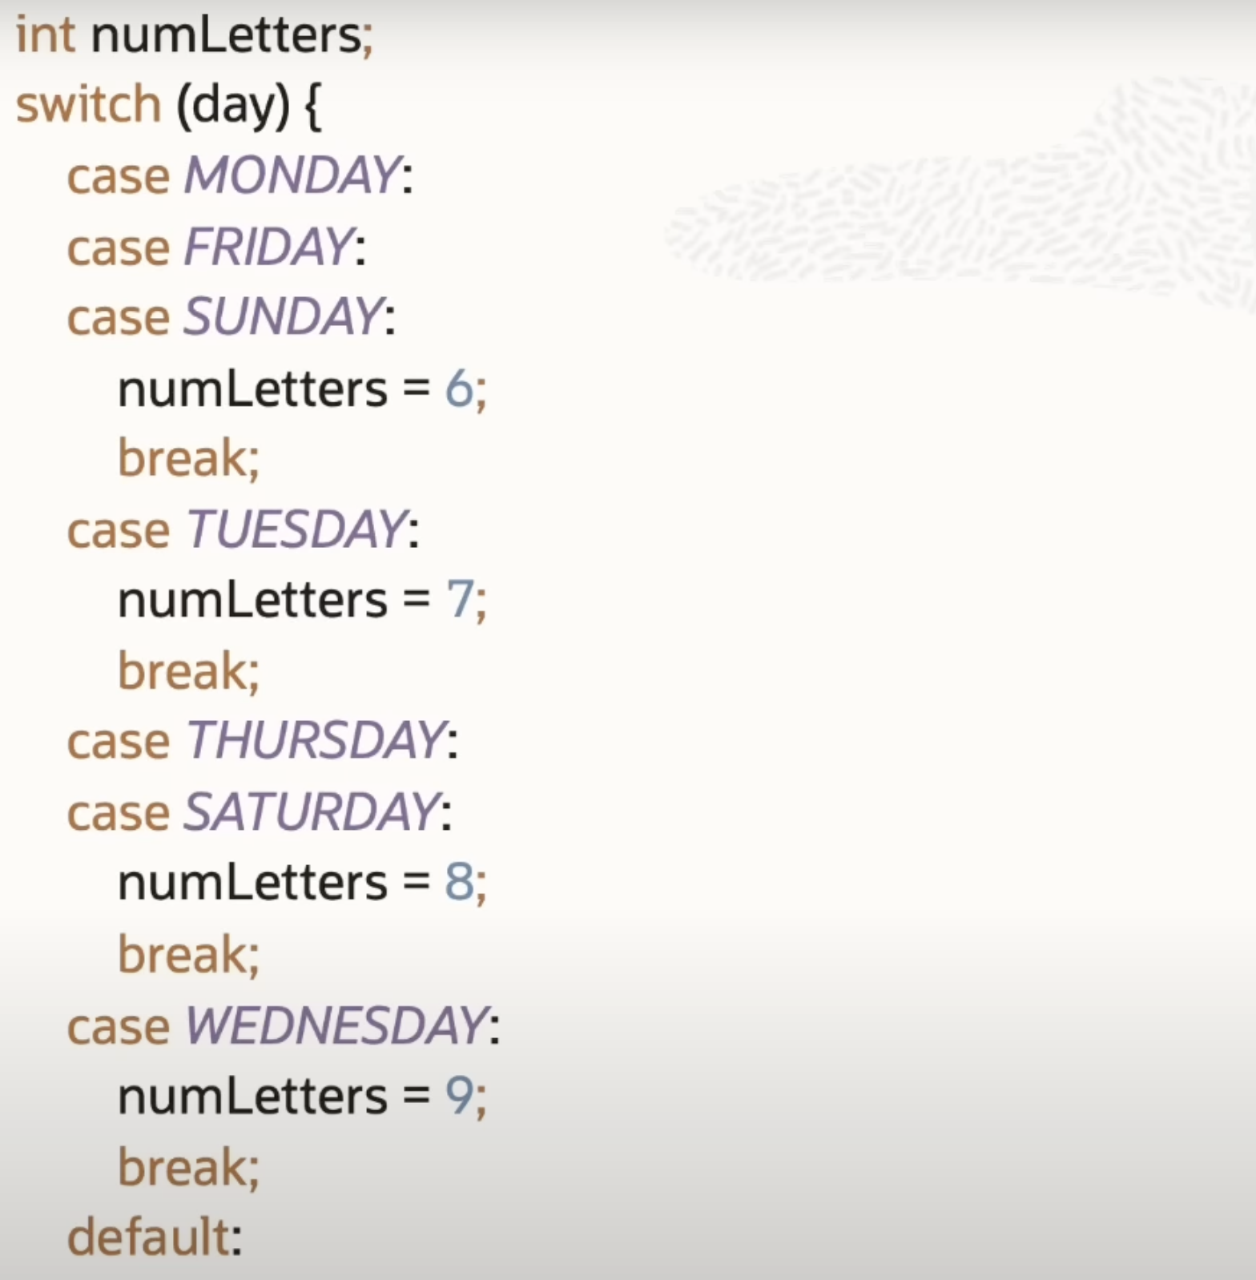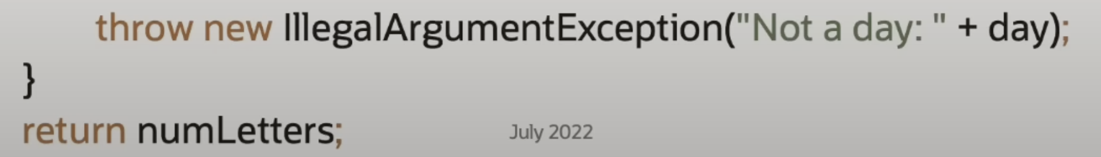

Above code can be written in switch expression as below:

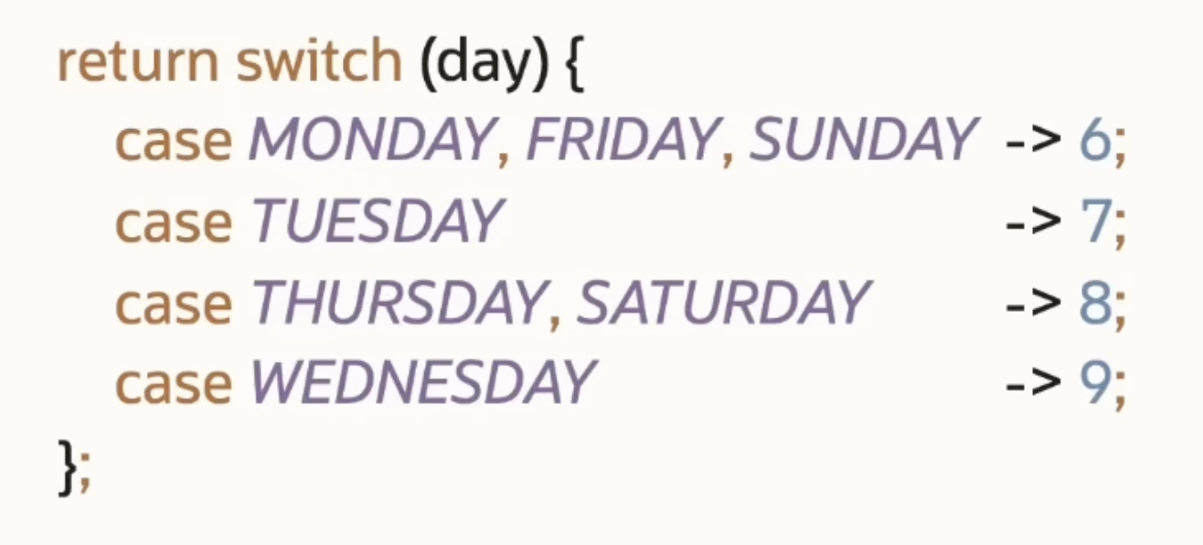

**Text Block JDK 15**

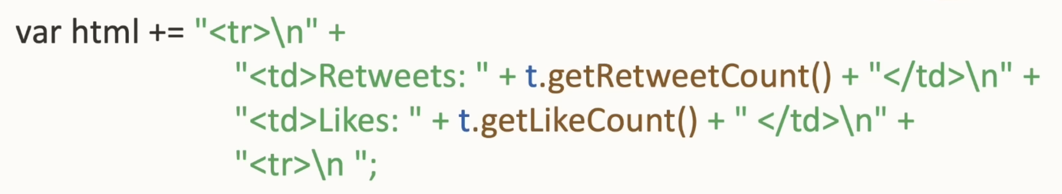

Above code can be written using Text Blocks as below:

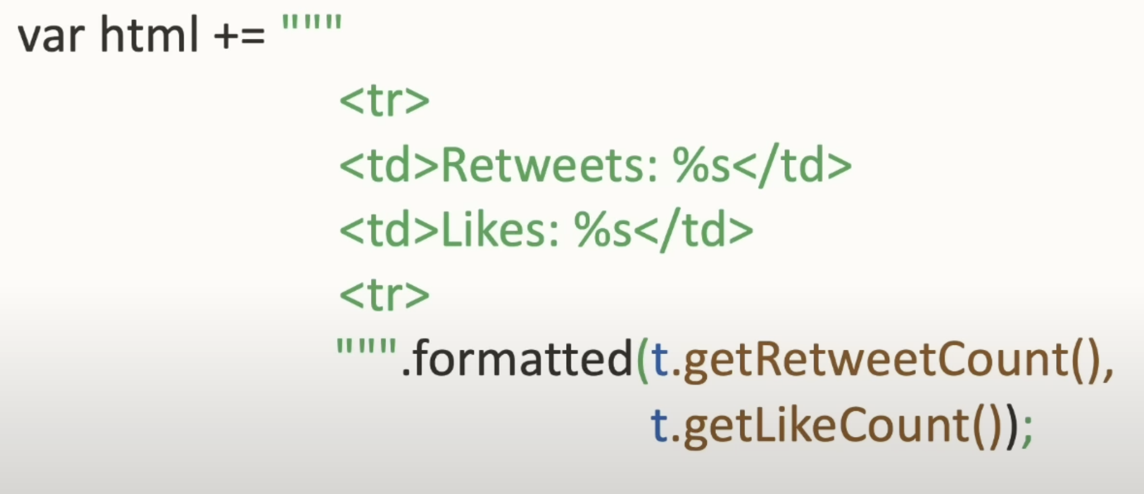

**Record Classes JDK 16**

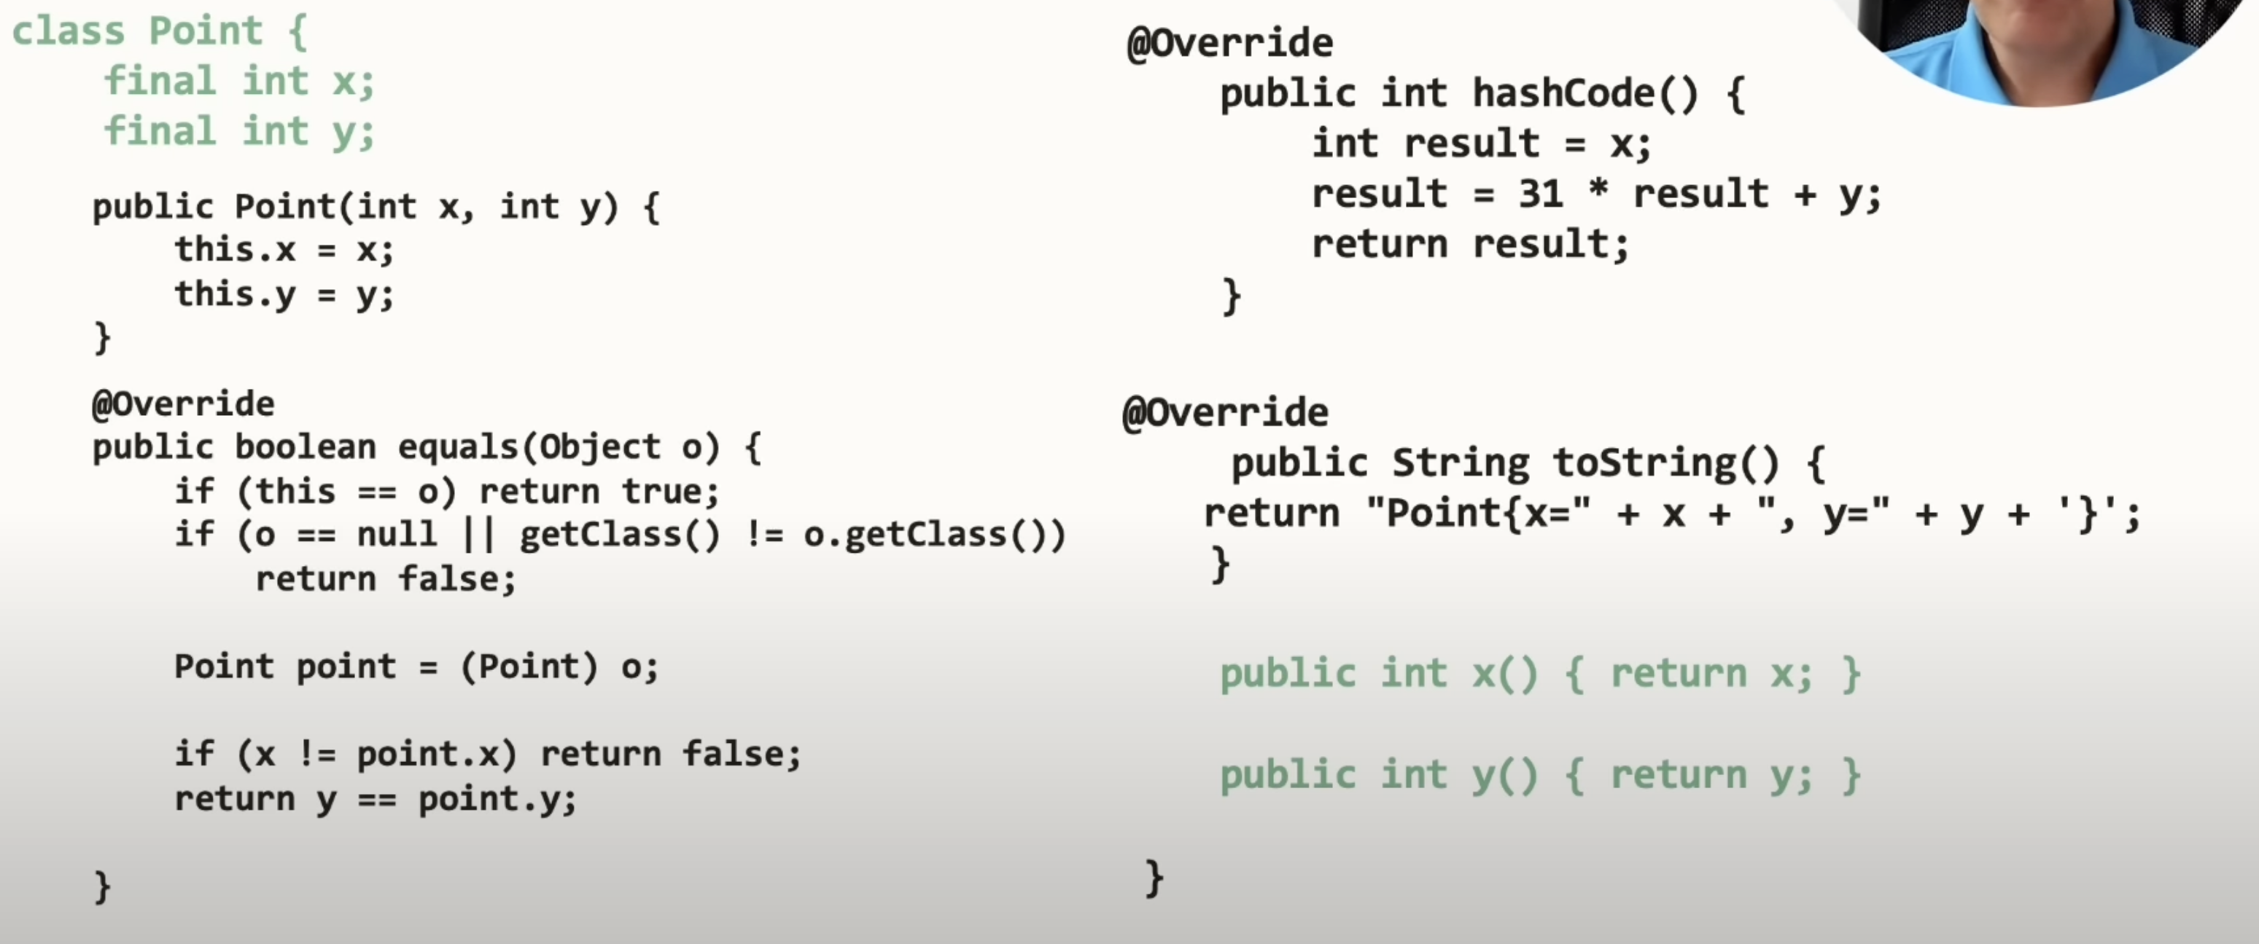

Above code can be written using Record classes as shown below:



Record class is a Final Class. *Constructer*, *getters*, *hashCode*, *equals* and *toString* are all provided automatically. The data is immutable, so there are no setter methods.

For example, if you want to do some validation using the constructer, then we can only write the constructer.

**Pattern Matching for instanceOf JDK 16**

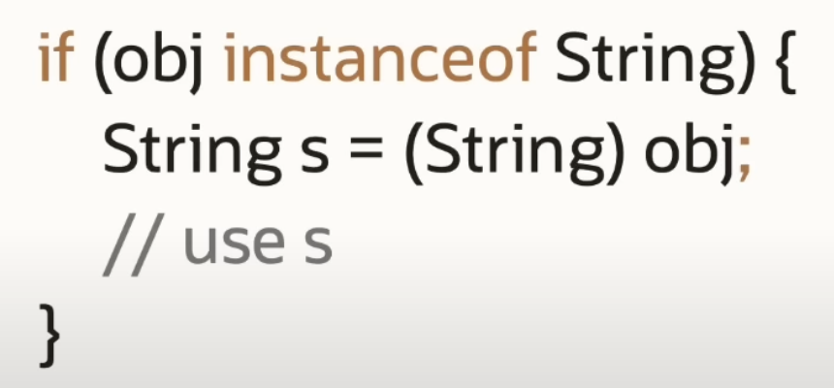

Above code can be written using Pattern Matching for instanceOf as below:

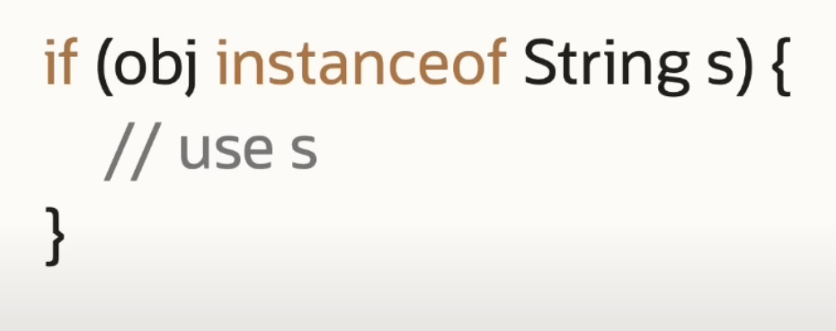

**Sealed Types (Classes and Interfaces) JDK 17**

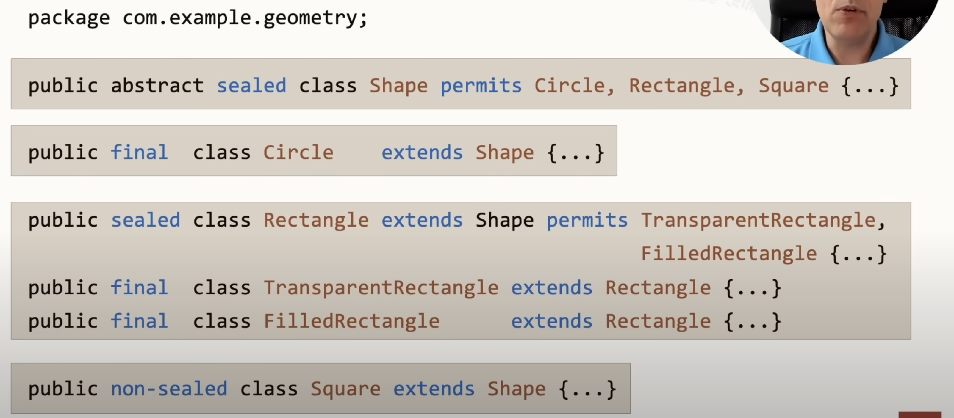

**Pattern Matching for Switch – Before Third Review in JDK 19**

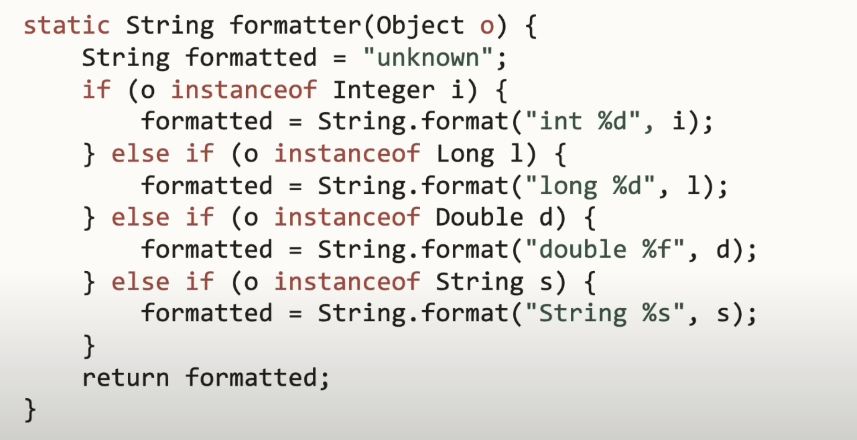

Above code can be written using Pattern Matching as below:

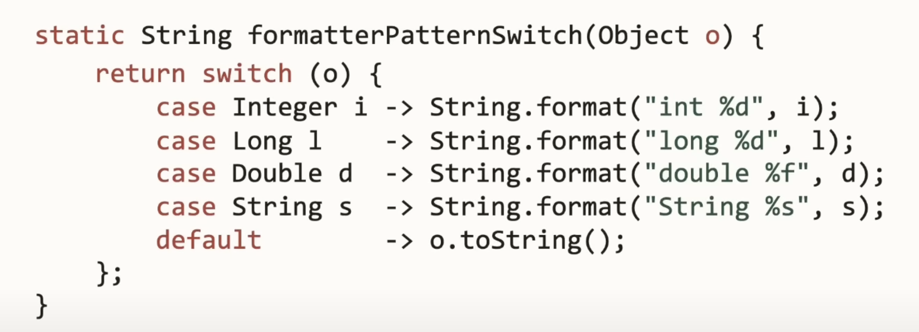

Even we can now do ***null*** matching as shown below:

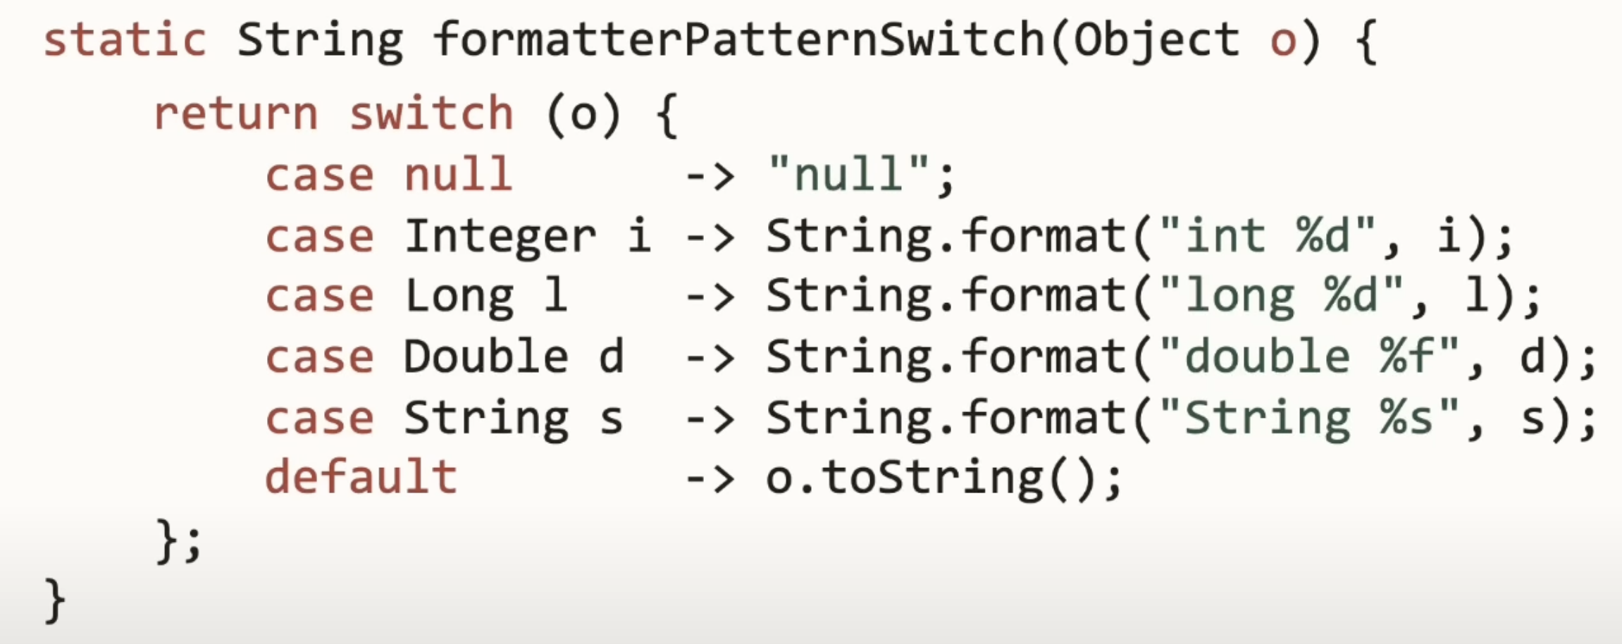

**Pattern Matching for Switch – Guarded Pattern:**

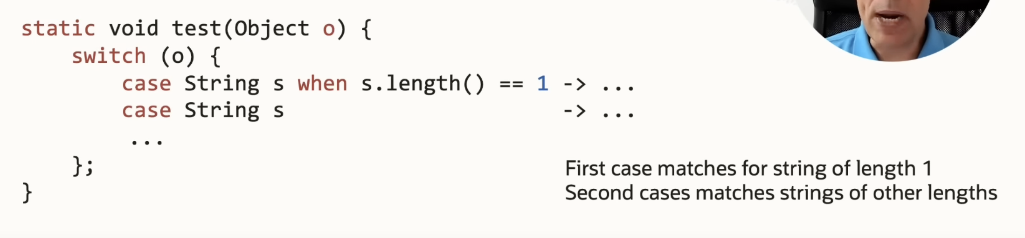

**Helpful NullPointerException JDK 14**

